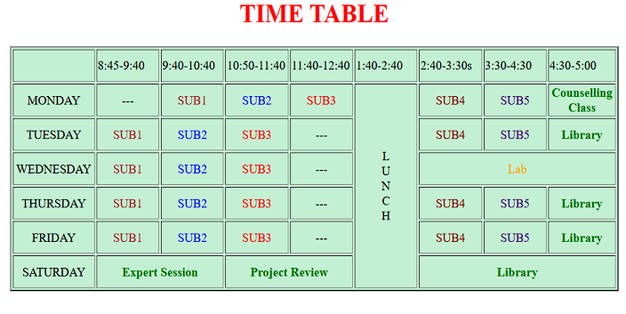

HTML Code:
<!DOCTYPE html>
<html lang="en">
<head>
<meta charset="UTF-8">
<meta name="viewport" content="width=device-width, initial-scale=1.0">
<title>Time Table</title>
<link rel="stylesheet" href="styles.css">
</head>
<body>
<div class="container">
<h1>TIME TABLE</h1>
<table border="=1">
<tr>
<th> </th>
<th>8:45-9:40</th>
<th>9:40-10:40</th>
<th>10:50-11:40</th>
<th>11:40-12:40</th>
<th>1:40-2:40</th>
<th>2:40-3:30</th>
<th>3:30-4:30</th>
<th>4:30-5:00</th>
</tr>
<tr>
<td>MONDAY</td>
<td>---</td>
<td class="subject red">SUB1</td>
<td class="subject blue">SUB2</td>
<td class="subject red">SUB3</td>
<td rowspan="6" class="lunch">LUNCH</td>
<td class="subject green">SUB4</td>
<td class="subject purple">SUB5</td>
<td>Counselling Class</td>
</tr>
<tr>
<td>TUESDAY</td>
<td>---</td>
<td class="subject blue">SUB2</td>
<td class="subject red">SUB3</td>
<td>---</td>
<td class="subject green">SUB4</td>
<td class="subject purple">SUB5</td>
<td>Library</td>
</tr>
<tr>
<td>WEDNESDAY</td>
<td class="subject red">SUB1</td>
<td class="subject blue">SUB2</td>
<td class="subject red">SUB3</td>
<td>---</td>
<td colspan="3" class="lab">Lab</td>
</tr>
<tr>
<td>THURSDAY</td>
<td class="subject red">SUB1</td>
<td class="subject blue">SUB2</td>
<td class="subject red">SUB3</td>
<td>---</td>
<td class="subject green">SUB4</td>
<td class="subject purple">SUB5</td>
<td>Library</td>
</tr>
<tr>
<td>FRIDAY</td>
<td class="subject red">SUB1</td>
<td class="subject blue">SUB2</td>
<td class="subject red">SUB3</td>
<td>---</td>
<td class="subject green">SUB4</td>
<td class="subject purple">SUB5</td>
<td>Library</td>
</tr>
<tr>
<td>SATURDAY</td>
<td colspan="2">Expert Session</td>
<td colspan="2">Project Review</td>
<td colspan="3">Library</td>
</tr>
</table>
</div>
</body>
</html>

Css code:
body {
font-family: Arial, sans-serif;
background-color: #f9f9f9;
display: flex;
justify-content: center;
align-items: center;
height: 100vh;
margin: 0;
}

.container {
width: 90%;
max-width: 1000px;
background-color: #e0f7fa;
border: 2px solid #009688;
padding: 20px;
border-radius: 8px;
text-align: center;
}

h1 {
color: red;
margin-bottom: 20px;
font-size: 24px;
}

table {
width: 100%;
border-collapse: collapse;
}

th, td {
border: 1px solid #009688;
padding: 10px;
text-align: center;
}

th {
background-color: #80deea;
color: #000;
}

td {
background-color: #e0f7fa;
}

.subject.red {
color: red;
font-weight: bold;
}

.subject.blue {
color: blue;
font-weight: bold;
}

.subject.green {
color: green;
font-weight: bold;
}

.subject.purple {
color: purple;
font-weight: bold;
}

.lunch {
writing-mode: vertical-rl;
transform: rotate(180deg);
font-weight: bold;
background-color: #b2dfdb;
}

.lab {
background-color: #ffffe0;
font-weight: bold;
}

td[colspan] {
background-color: #e0f2f1;
font-weight: bold;
}

